**Evolutionary Robotics Final Project**

P. Alexander Burnham

16, April 2018

Does robot joint and limb morphology affect evolutionary response using a distance-based fitness function?

**Time Line 6) Work on combining all of these functionalities into an object based program**

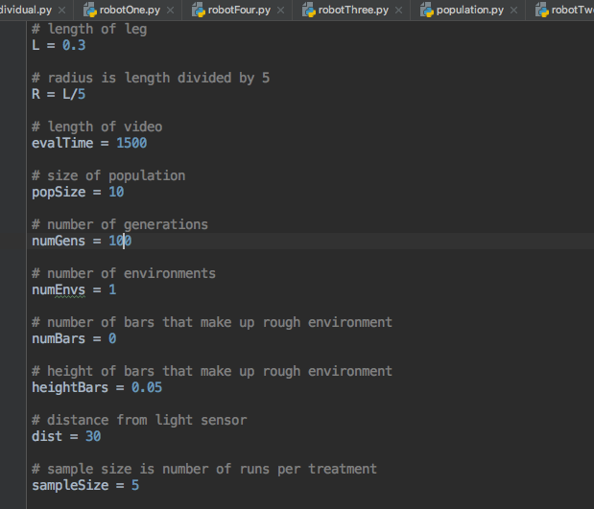This week I optimized my program and prepared to conduct the experiment. I set all of the controls to be constants in the constants.py file so that I can change the parameters of the experiment from one place (Figure 1). I have four robot files that code for each of the different ANNs and morphologies and implemented an outer for loop that runs each of the robots for a predetermined sample size. All of these fitness values for each run are stored in a matrix and exported as a .csv file for analysis in R. The controllers are saved with unique names as individual files for each “best” controller from each run so that they can be reevaluated in other environments.

All bugs in the program are fixed at this point. All robots function properly and all runs go to completion without throwing indexing errors. The ability to run these programs overnight with large population sizes and generation sizes repeatedly will increase my sample size and allow me to collect as many useful data as possible for each of my eight treatments. I have begun to think about analysis and in addition to fitness curves, I believe time to max fitness or to an estimated asymptote on the curve would be a diagnostic measure that ignores overall fitness but compares how long it takes each robot to reach its own optimum.

Figure 1: Constants that allow for control of experimental design from one single point.

In conclusion, I am now ready to start conducting my experiment on schedule for next week.